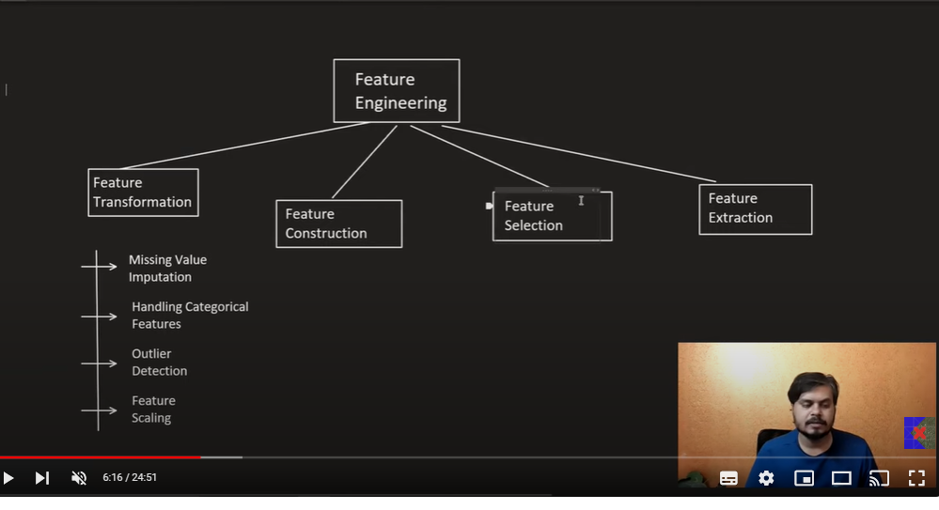

C:\Users\user\OneDrive\Desktop\ml\WK13Session on Filter based Feature Selection.pdf

Notebook:

[C:\Users\user\OneDrive\Desktop\ml\](C:\\Users\\user\\OneDrive\\Desktop\\ml\\WK13Session on Filter based Feature Selection.pdf)[wk13filter-based-feature-selection.ipynb](C:\\Users\\user\\OneDrive\\Desktop\\ml\\WK13Session on Filter based Feature Selection.pdf)

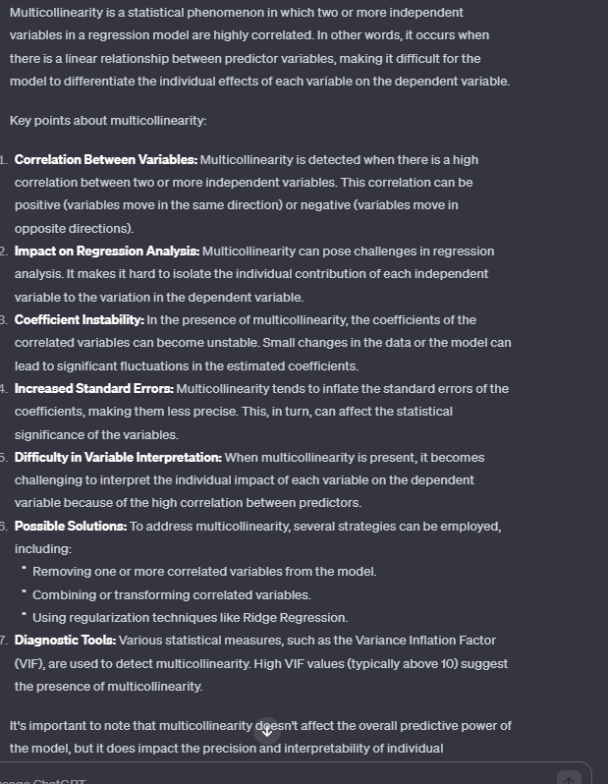

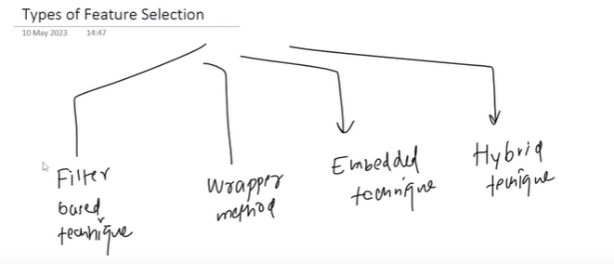



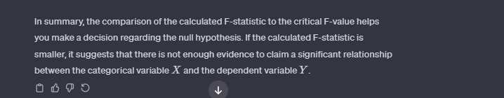



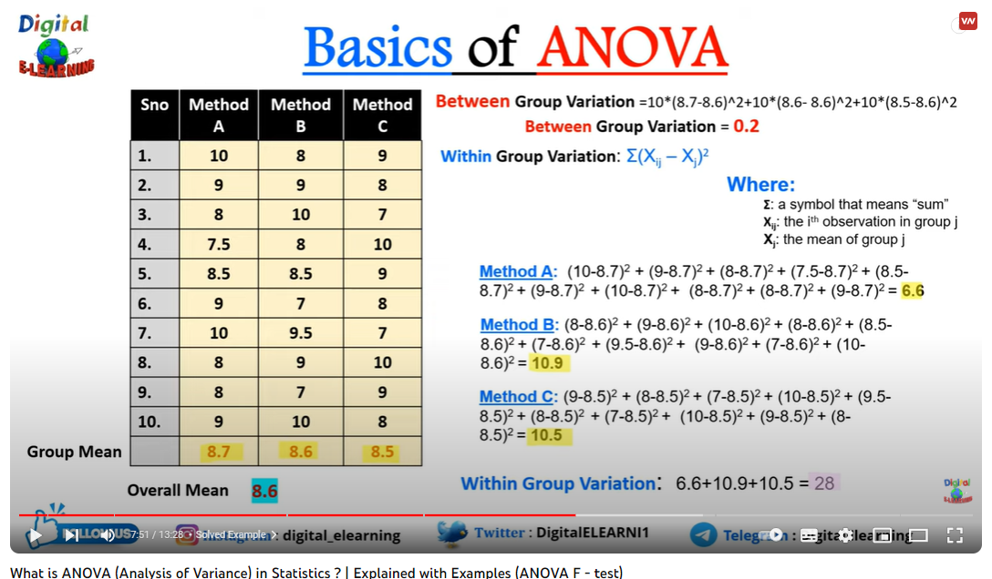

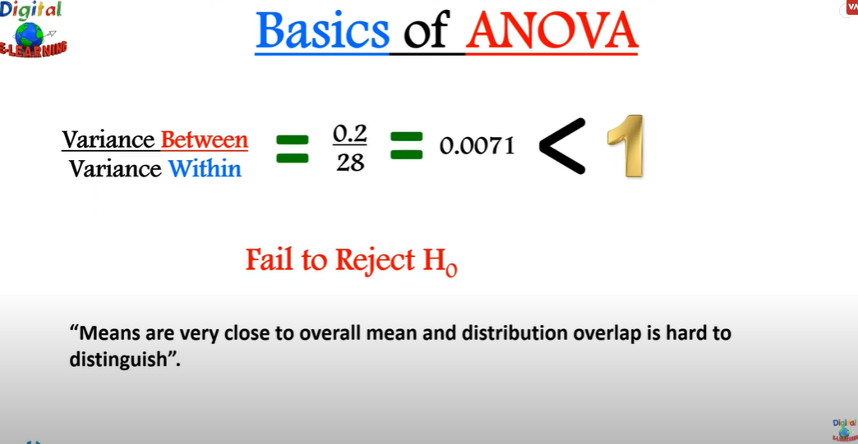

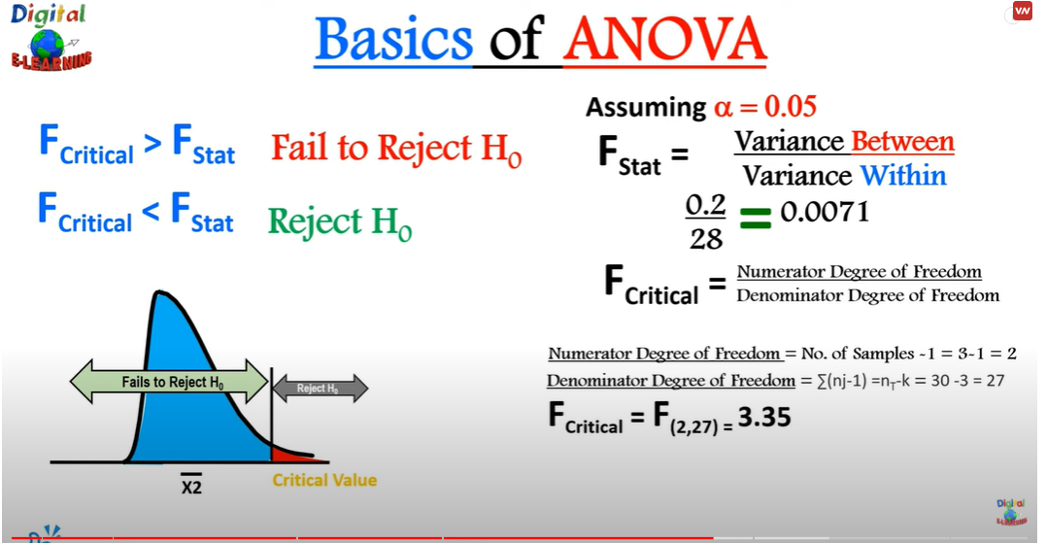

dfhkghghglghffkfgkfkgjk

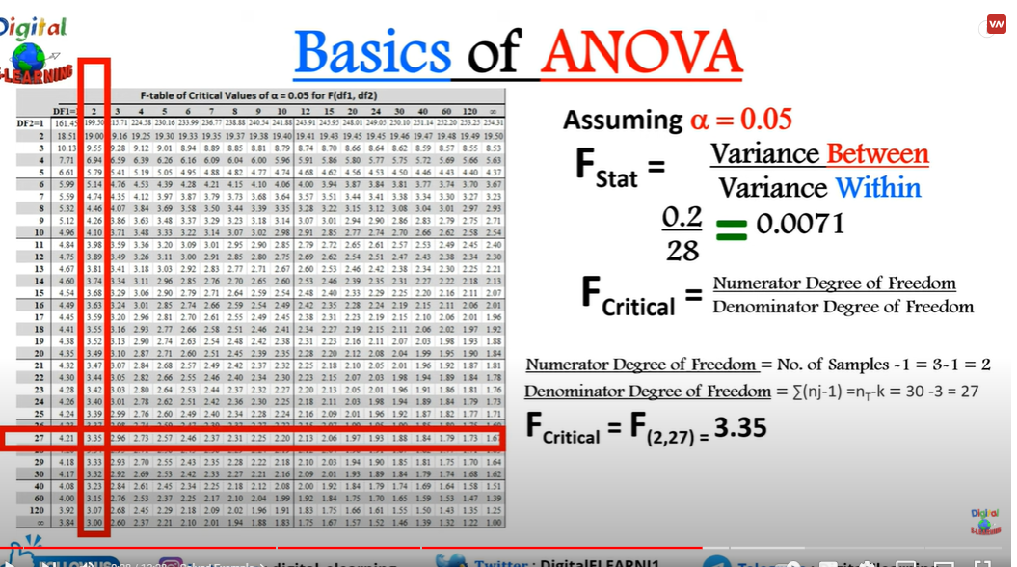

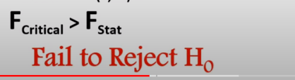

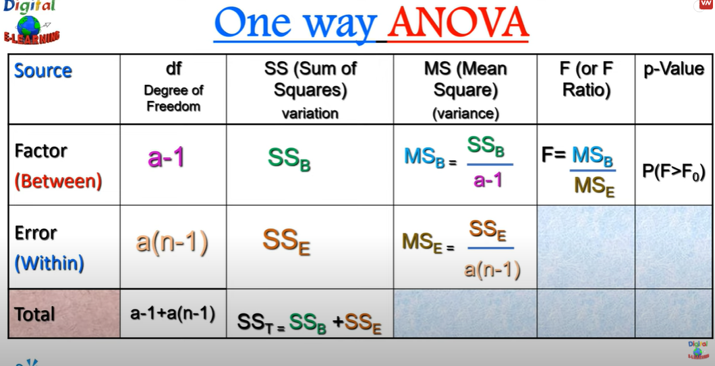

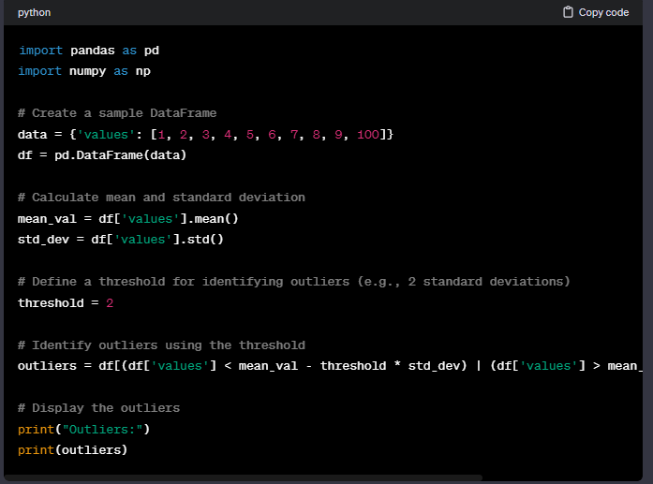

**WRAPPER METHOD**

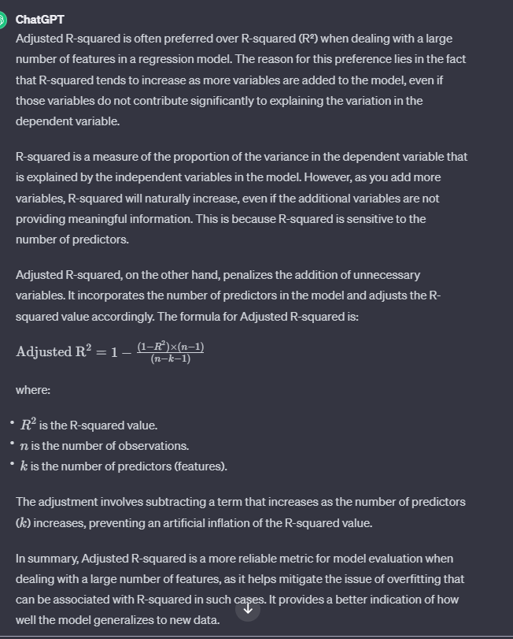

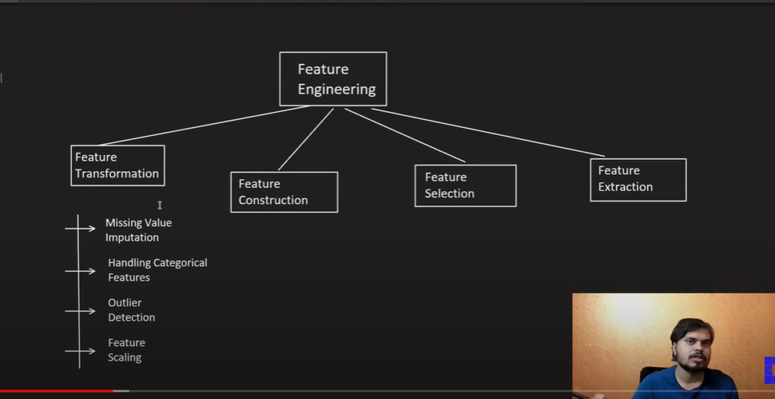

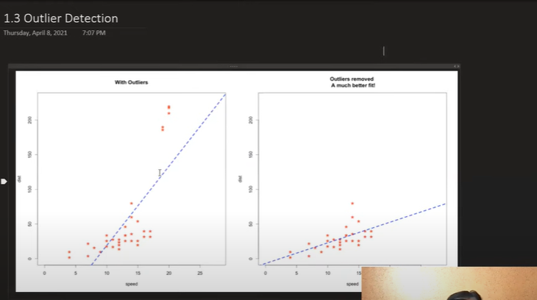

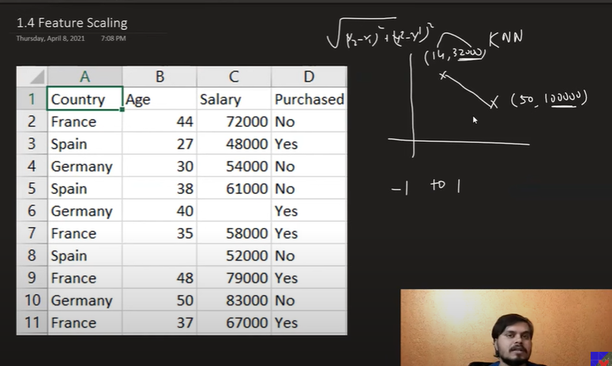

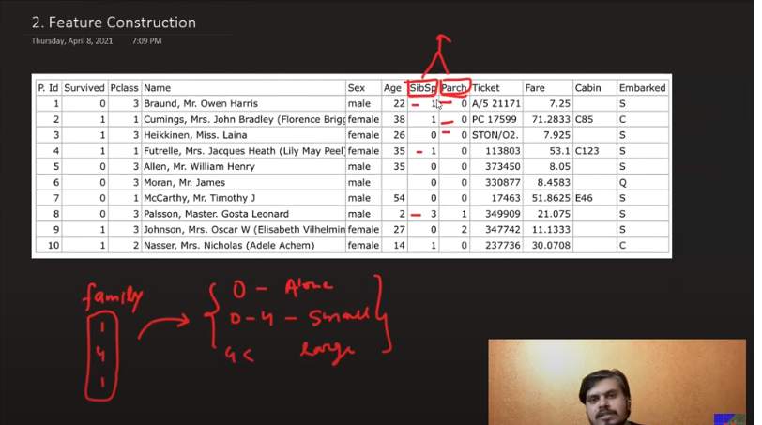

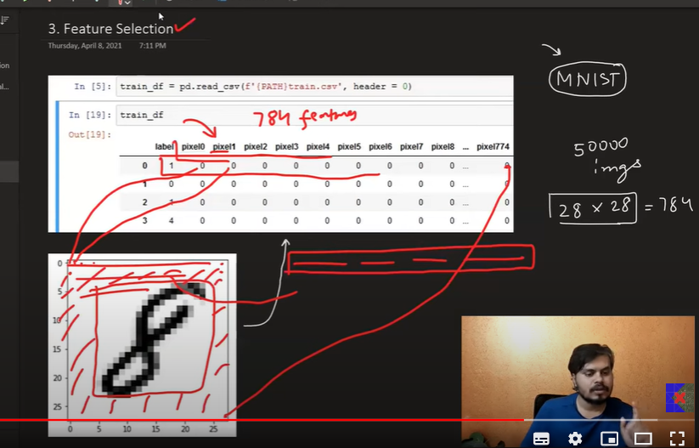

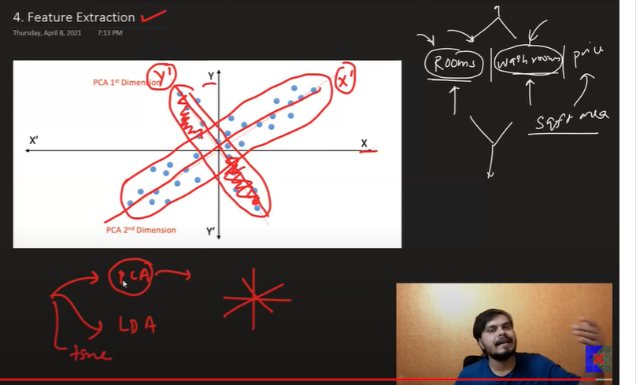

**FEAUTRE SCALING**

